Database selection and tables:

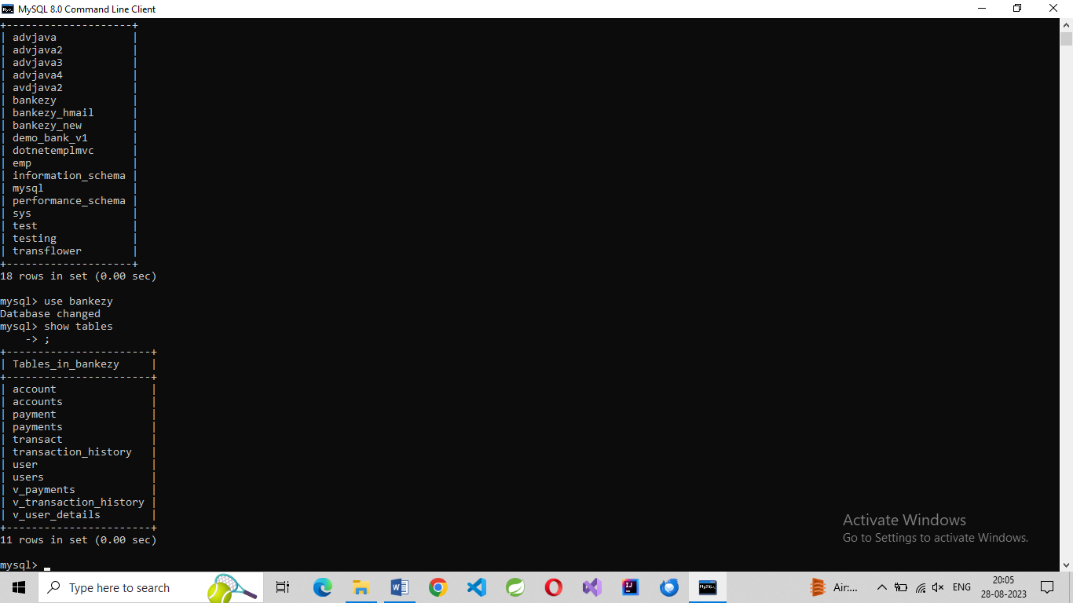

Desc accounts and desc payments:

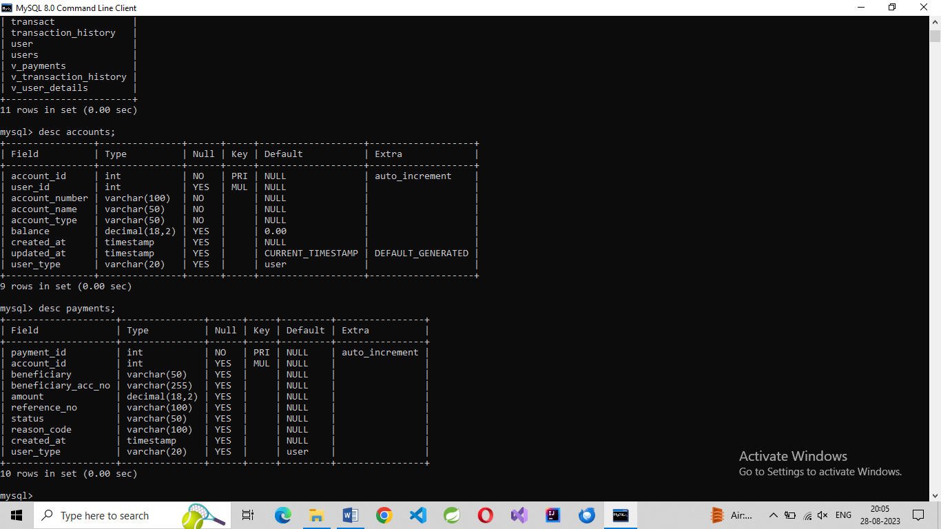

Desc transaction_history and desc users:

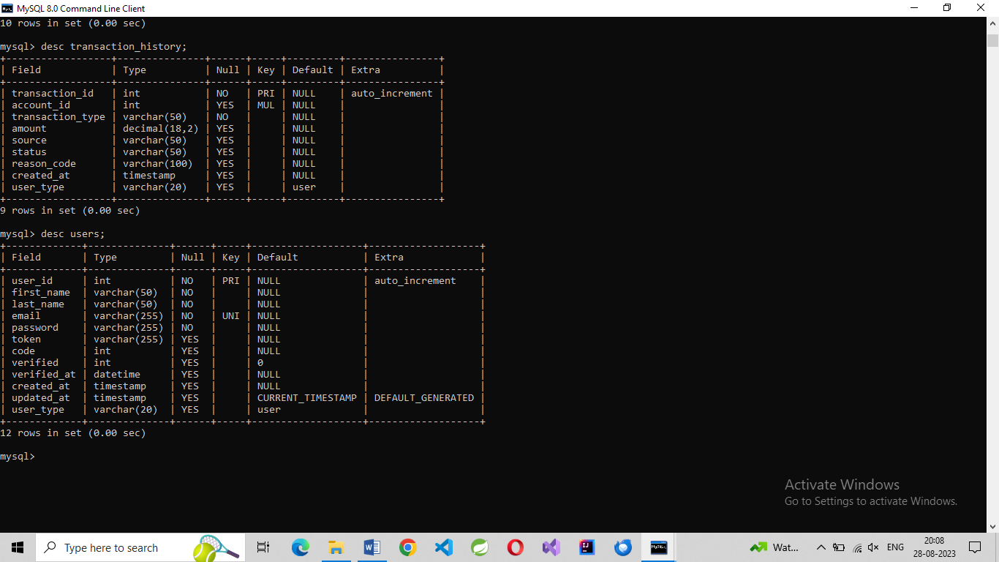

Desc v_transaction_history and desc v_payments:

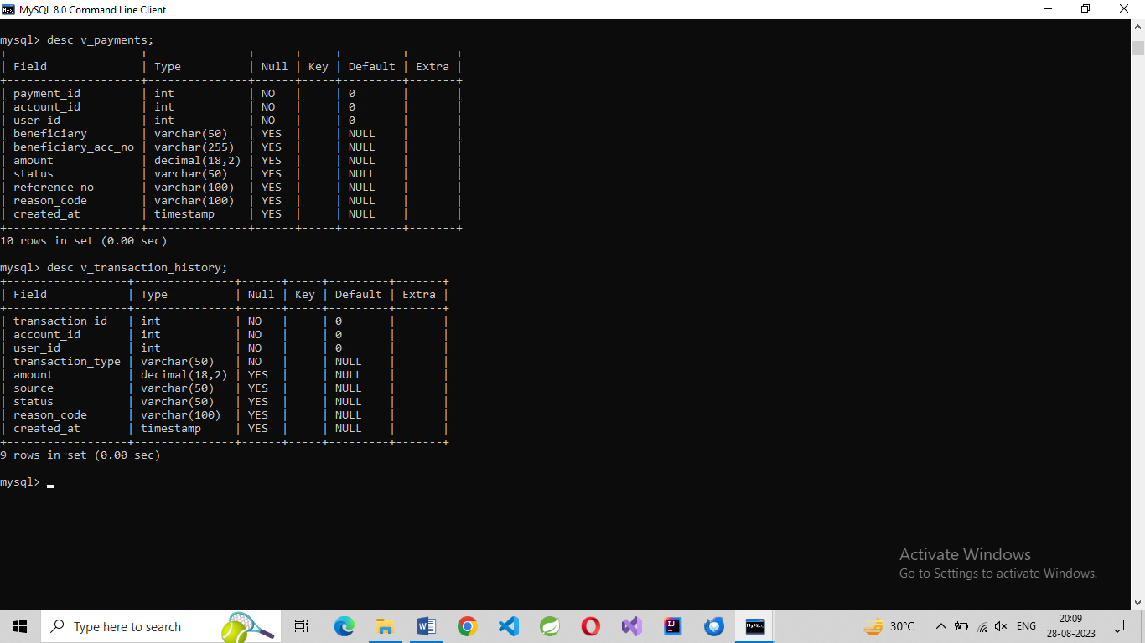

Desc v_user_details;

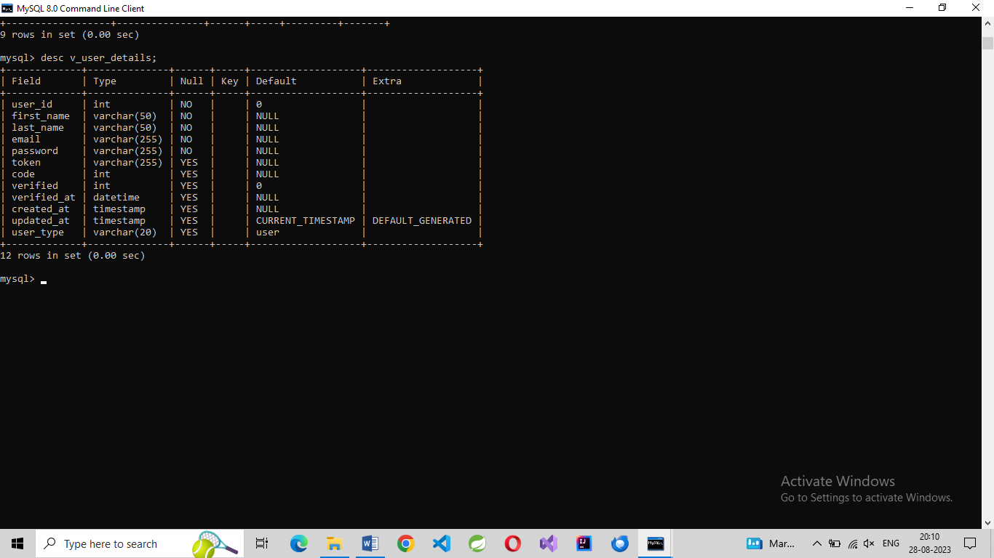

Select * from accounts;

Select * from payments;

select * from transaction_history;

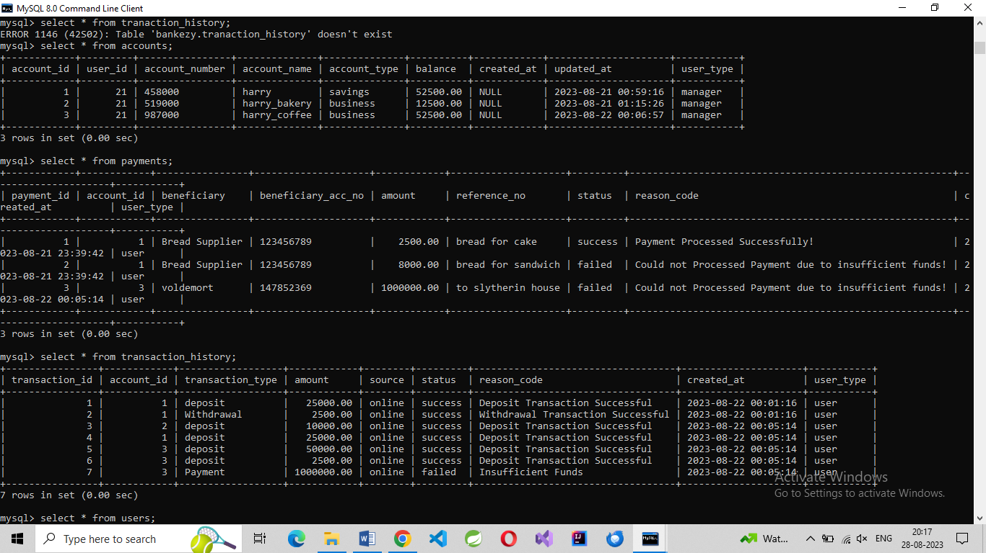

Select * from users;

Select * from v_transaction_history;

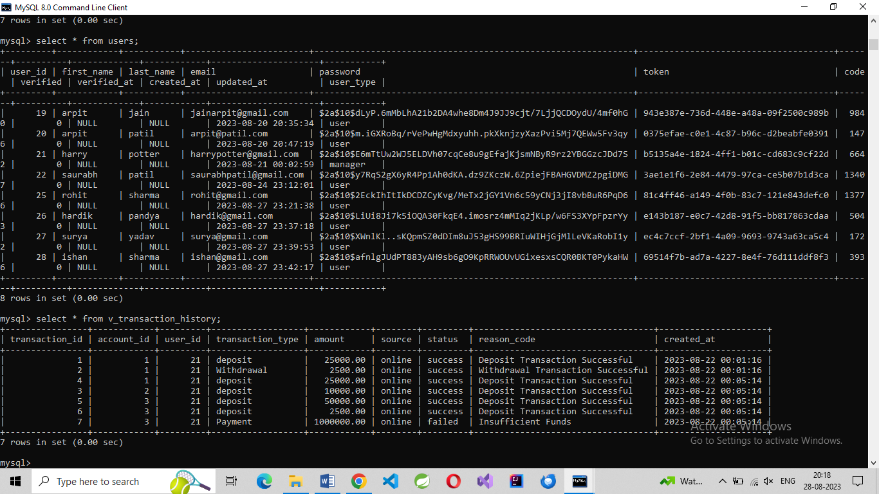

Select * from v_payments;

Select * from v_user_details;

